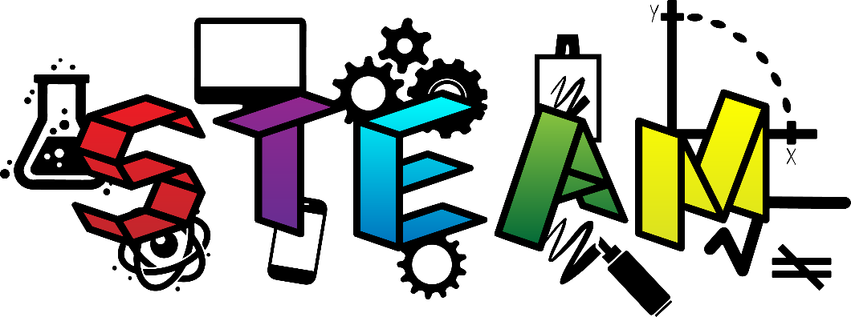

Enrichment Opportunities
2023/2024 School Year

Dear Families,
We have expanded our preschool program to include afternoon Enrichment Opportunities. Many of you asked if it was possible to attend full day preschool before beginning Kindergarten, and we are making that happen!
If you have a child(ren) enrolled in either the AM Pre-K or the AM 4’s class for next school year, you have the option to add on 2 enrichment afternoons (Tuesday/Thursday).
What exactly does this mean?
- It means that your child(ren) will get to stay at the Preschool on those 2 days for lunch and get to experience MORE in the afternoon…more art, more math, more music, more science, etc.

- What is STEAM?

  - Science, Technology, Engineering, Arts and Mathematics

The space is limited (12 students), so this option is first come, first serve. The STEAM Enrichment option is included on the Registration Form. You DO NOT have to pay another registration fee. However, volunteerism is requested once a month.
Thank you, and we hope to see many of you a little bit MORE next year!
Sincerely,
FPC Preschool Staff
300 S Main Street
PO Box 1038
Greensburg, PA 15601

